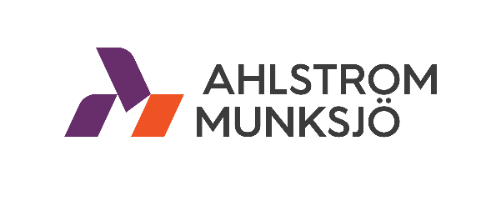

Ahlstrom-Munksjö Hosts Open Interview day at Nicolet Plant in De Pere, WI USA
Monday, July 15, 2019: DE PERE, WI – The Ahlstrom-Munksjö Nicolet Plant in De Pere, Wisconsin will be hosting open interviews on Wednesday, July 24, 2019.
The fair will be held at the De Pere Community Center in the Oak Room located at 600 Grant Street, De Pere, WI 54115 from 10 a.m. to 6 p.m.
“If you are looking for an exciting career opportunity that provides excellent opportunities for development and growth, a job in the paper industry is where to find it,” said Chris Williams, Nicolet Plant Manager. “Our manufacturing positions offer many opportunities for advancement and increased pay, in addition to providing our team members with a positive and safe atmosphere.”
New team members receive starting wages of $18.45 per hour and receive $19.48 per hour following a 90-day probationary period.
If you would like to be considered for a position, please call Ahlstrom-Munksjö’s Human Resource Department at 920.337.1256. Walk-ins are welcome but first preference will be given to those candidates who schedule in advance.

#####
For media relations details, please contact:
Addie Teeters, Communications and Marketing Manager,
Ahlstrom-Munksjö North America Specialty Solutions
Tel.: +1 920 766 8304
Mobile: +1 920 202 445 5114
Email: addie.teeters@ahlstrom-munksjo.com
Ahlstrom-Munksjö is a global leader in fiber-based materials, supplying innovative and sustainable solutions to its customers. Our mission is to expand the role of fiber-based solutions for sustainable everyday life. Our offering includes filter materials, release liners, food and beverage processing materials, decor papers, abrasive and tape backings, electrotechnical paper, glass and carbon fiber materials, medical fiber materials and solutions for diagnostics as well as a range of specialty papers for industrial and consumer end-uses. Our annual net sales are about EUR 3 billion and we employ some 8,000 people. The Ahlstrom-Munksjö share is listed on the Nasdaq Helsinki and Stockholm.

